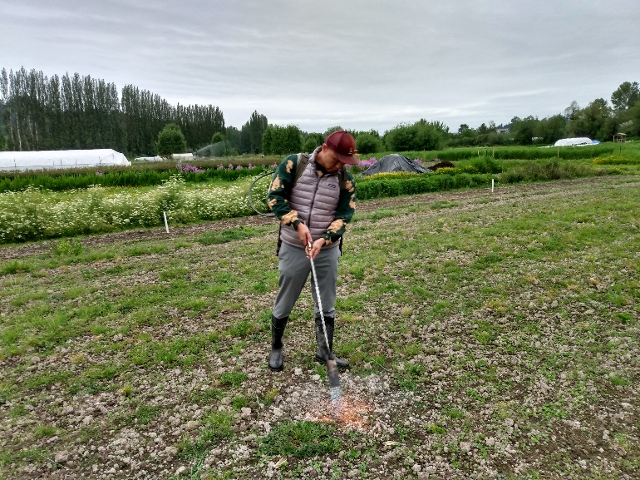
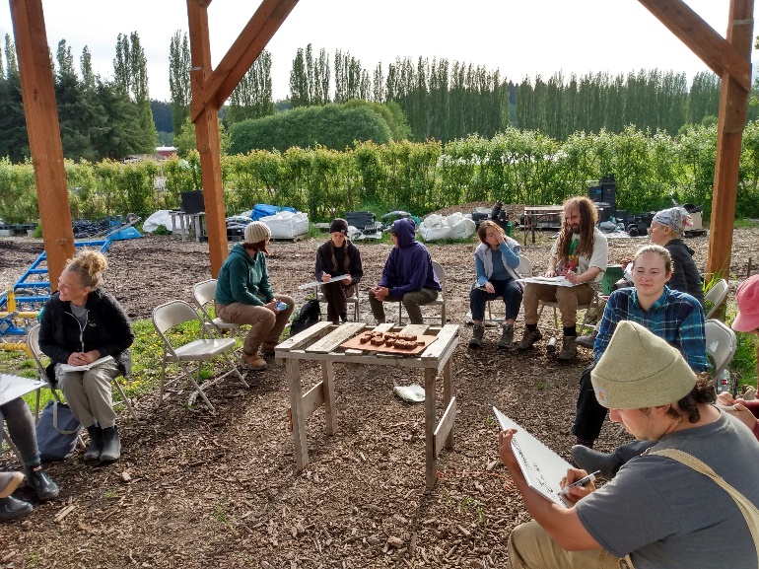
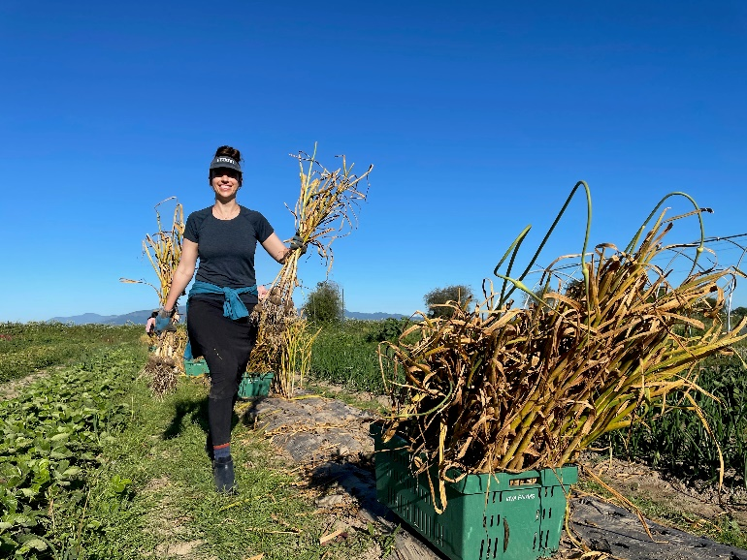
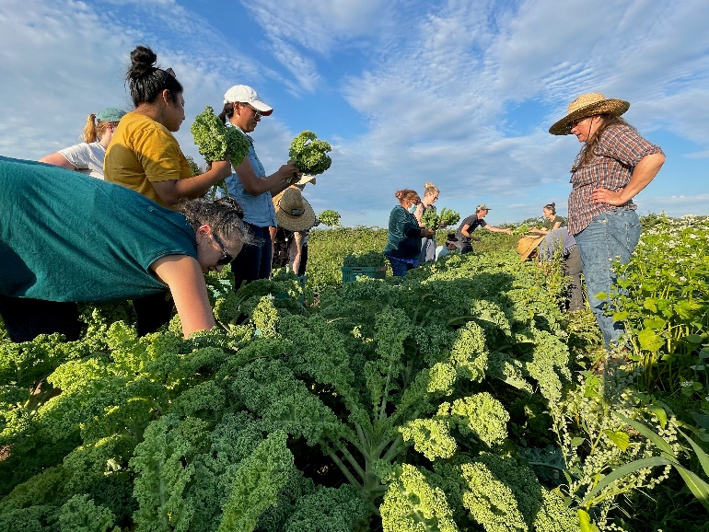

Practicum in Sustainable Agriculture

Practicum in Sustainable Agriculture Program Description
The Practicum in Sustainable Agriculture (Practicum) is a hands-on, applied course in certified Organic production and small farm business management. In Skagit County, the Practicum is a bilingual training, offered in both English and Spanish. The Practicum takes place over 8 months from early April through mid-November and corresponds with 3 academic quarters – Spring, Summer and Fall. The Spring and Summer quarters focus on production practices and farm operations and the Fall quarter moves into applied business management.
As a cohort, participants will go through an entire farming season and explore the fundamentals of:
- Certified Organic Production
- Sales & Marketing
- Crop & Farm Planning
- Soil Health & Fertility Management
- Seed Propagation & Greenhouse Management
- Cultivation & Weed Management
- Pest & Disease Management
- Irrigation
- Harvest & Post-Harvest Operations
- Food Safety
Participants will also examine the basics of farm business management, including:
- Business Planning & Set-Up
- Basic Bookkeeping & Financial Recordkeeping
- Profitability Analysis
- Regulatory Compliance
- Access to Capital
- Insurance & Farm Taxes
Upon successful completion of the Practicum, participants will be eligible to apply to participate in the Viva Farms farm business incubator program. The incubator program provides farmers with access to land, infrastructure, equipment, marketing and capital in order to grow a successful farm business.
For more information, please visit VivaFarms.org.

Options for Course Registration
- Viva Farms – Register directly through Viva Farms to take the course at either our Skagit or King County location. Successful completion will earn a Certificate of Completion from Viva Farms and eligibility to apply to start an independent farm business at Viva Farms.
- Seattle Central College – Viva Farms partners with the Continuing Education Division to offer the Sustainable Agriculture Applied Planning & Management Certificate of Completion. This certificate is taught at our King County Student Farm in Woodinville, WA, and awards 20.4 Continuing Education Units (CEUs) to students who attend regularly and demonstrate satisfactory course and field work.

Application, Review Process, and Registration
Complete the application outlined in the following pages, detailing your previous education and experience in sustainable agriculture and your future goals. References must be provided to confirm applicants’ skill and experience level.
Applications are due February 24th, 2023.
Please submit completed applications to Viva Farms’ admissions team directly, using information below:
- Email – include your name and “Viva Practicum Application” in the subject line and mail to practicum@vivafarms.org
- If email is not an available option to submit the application, please call (360) 969-7191 ext. 2 for other options for submission
Viva Farms’ admissions team will review applications in the order they are received, and provide notification of acceptance on a rolling basis. At the discretion of Viva Farms’ admissions team, applicants may be required to complete additional application steps, including an interview and a visit to the Practicum farm parcel in the location where they have applied.
Viva Farms’ staff are available (by appointment) to provide assistance in completing the application. To receive assistance, contact: practicum@vivafarms.org, or call (360) 969-7191 ext. 2.

Frequently Asked Questions
How much does the Practicum program cost?
- Viva Farms Registration
  - Taking the practicum from Viva Farms directly costs $1,200 for the entire 8-month program.
  - Payment installation plans and partial or full scholarships are available on a financial need basis.
- Seattle Central Registration
  - Students who would like to earn continuing education credit through Seattle Central College and receive an SCC Sustainable Agriculture Applied Planning & Management Certificate of Completion will pay an additional $200 administrative fee on top of the $1,200 tuition, for a total of $1,400.

When does the Practicum begin and end?
- The Practicum in Sustainable Agriculture begins in early April and runs through late November. The exact start and end dates will be clarified in subsequent communications with accepted participants. We encourage students to participate in farm activities throughout the course to maximize their exposure to the farm through the changing seasons.

Where does the Practicum take place?
- The Practicum is offered in Skagit County (English and Spanish interpretation available), and in Woodinville in King County (English only).
- Participants will apply their learning and practice techniques of sustainable agriculture on certified Organic land at the Viva Farms location where they choose to apply.

*Due to the Covid-19 pandemic, portions of the course may be held online via Zoom. Participants must have the technological capacity to participate in remote video learning. *

What is the time commitment of the program? Can I work a job at the same time?
- Each week, there will be 2 hours of instruction on Tuesday evenings from 5:30pm-7:30pm, so as to accommodate normal working hours. Participants will be required to complete independent work hours for an additional 4 hours per week on average throughout the course. Often, the field-based independent hours do not start until several weeks into the course and end several weeks before the course, corresponding with the demands of the farming season. So, the total time commitment is a total of 6 hours/week on average, but not each and every week. In the past, participants have enjoyed farming so much that they spend more time on the farm than required!
- The timing of independent work hours will vary with the farming season. Independent hours ramp up as task demand increases and decrease as the season tapers off, but should average out to 4 hours per week each quarter. As with any farm, students should anticipate working more during the peak summer season, from June to September. Independent hours are independent and often times, course instructors are not available during the times that participants choose to come out. Instructors will offer times outside of class, during business hours that they are available (“office hours”), so that participants wanting to spend more time with instructors can prioritize coming during those hours. Participants wanting to complete their independent hours during the early mornings, evenings, weekends, or outside of normal business hours should expect to be working on their own, and instructors will be available to plan activities and share any necessary instructions in advance of the student’s arrival.
- It is important to remember that the Practicum parcel is part of a working farm. We will be harvesting to order for customers of Viva Farms and must be able to maintain both high quality and consistency. We ask for high commitment and for participants to reliably arrive on time and be ready to work during their scheduled independent hours.
- Finally, the Practicum is a course with a competitive application process and there is often more demand for the program than spaces. Please be realistic in your capacity to commit to the time requirements for the course and know that there is a waiting list of others that would like to take the course.

Do I need to complete the entire program in order to apply to the Viva Farms business incubator?
- To participate in the incubator program, participants must demonstrate competency in the knowledge and techniques introduced during the Practicum. The Practicum is a valuable way to apply the fundamentals of sustainable production and small-farm business management, as well as to learn the particulars of opening a farm at Viva Farms in a relatively low-risk environment. For that reason, we strongly encourage all prospective incubating farmers to participate in the entire Practicum and complete all of the course requirements, especially independent work hours.
- We will give preference to prospective farmers based on satisfactory attendance and participation. Space in the incubator is not guaranteed even upon successful completion of the course – availability of farmland in the incubator will be subject to the conditions going into the following season.
- There are, however, some cases where participants can “test out” of Practicum requirements. To do so, prospective incubator farmers must demonstrate significant previous experience in Organic farm production and business management. Depending on experience, applicants for the incubator may be required to take only a portion of the Practicum to qualify for the incubator.

For more information, visit VivaFarms.org. For further questions, contact: practicum@vivafarms.org or call (360) 969-7191 ext. 2.

2023 Practicum in Sustainable Agriculture Application

Applicant Information
Name: First Middle Last
Address: Street Address City State Zip
Phone Number(s): xxx-xxx-xxxx
Email Address: email@example.com

How did you learn about the Practicum?
Click or tap here to enter text.
At which location would you like to take the Practicum?
☐King County ☐Skagit County
Are you planning on taking the course directly from Viva Farms or through Seattle Central College?
☐Viva Farms ☐Seattle Central
Are you planning on attending the entire course (early April – late November)?
☐Yes ☐No
If you answered No, please explain why and note which quarters you plan on attending:
Click or tap here to enter text.
Farm labor can be difficult physically. Work happens outside, in variable weather conditions and can begin early in the morning or run late into the evening. There are often repeated motions involving bending over, working with hazardous tools, and regular lifting of up to 50 lbs.
Can you meet the physical requirements of the Practicum? ☐Yes ☐No
Do you have any accessibility needs or accommodations that would aid in your participation in the Practicum?
Click or tap here to enter text.
Viva Farms offers scholarships on a limited basis based on economic need, military service, etc. Are you interested in learning more about scholarship opportunities? ☐Yes ☐No
Between April and November, Practicum students are expected to attend class one evening each week for two hours. In addition, students are required to spend an additional 4 hours minimum participating in independent activities on the farm.
Can you meet the time commitments of the Practicum? ☐Yes ☐No
Please identify how you plan to meet these requirements on a weekly basis, using the calendar below. This is preliminary and we anticipate this plan to change once the course starts.
Monday | Tuesday | Wednesday | Thursday | Friday | Saturday | Sunday
Click or tap here to enter text. | Click or tap here to enter text.  Practicum Class 5:30-7:30pm | Click or tap here to enter text. | Click or tap here to enter text. | Click or tap here to enter text. | Click or tap here to enter text. | Click or tap here to enter text.

Previous Experience
- Please describe any previous and relevant experience in agriculture. This can include personal experience, work experience, any formal or informal education or training background (schools, workshops, trainings, internships), or lived experience in agriculture.
Click or tap here to enter text.
Goals and Outcomes
- The Practicum focuses on teaching the foundations of sustainable agriculture. Please describe your interest in, and commitment to, certified Organic and sustainable farming practices.
Click or tap here to enter text.
- Please explain how this practical, hands-on training will fit into your personal and/or professional goals.
Click or tap here to enter text.
- Do you intend to apply to the Viva Farms incubator program after completing the Practicum in Sustainable Agriculture? ☐Yes ☐No ☐Unsure
Is there anything else relevant to your application that you would like to share or want the selection team to know?
Click or tap here to enter text.

References
Name | First Last
Organization/Company | Organization
Title and Relation | Title Relation (to applicant)
Contact Info | Phone Number and/or Email

Name | First Last
Organization/Company | Organization
Title and Relation | Title Relation (to applicant)
Contact Info | Phone Number and/or Email

Declaration
In applying for participation in Viva Farms’ Practicum in Sustainable Agriculture, I confirm that the information I have provided in this application is accurate and complete.

Viva Farms is committed to maintaining a welcoming, respectful, and inclusive environment for its diverse community of farmers, staff, students, volunteers, and partners. Viva Farms provides equal opportunity for its educational programs and activities and does not discriminate against individuals on the basis of race, color, national origin, religion, sex, age, pregnancy, disability, marital status, military or veteran status, genetic information, sexual orientation, gender expression or identity, or any other status or condition protected by applicable federal, state, or local laws.

Click or tap to enter a date.
Signature Date

